- Bluebook Page89 May 2019 variant two task3:

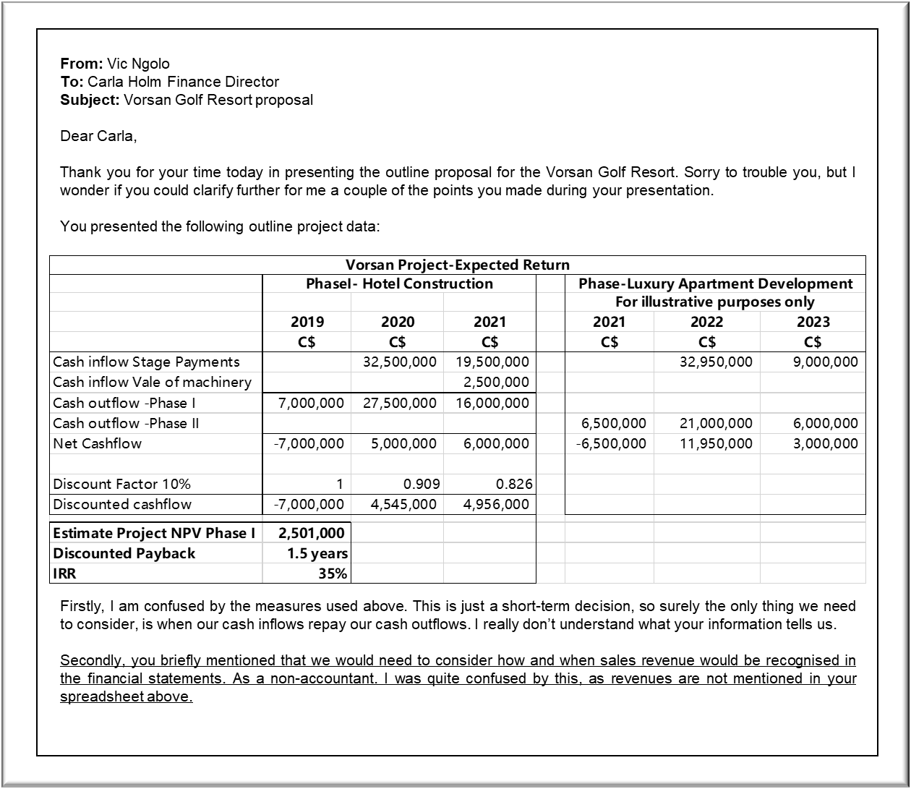MANAGEMENT CASE STUDY MAY 2019 EXAM ANSWERS

Variant2 Task3
These answers have been provided by CIMA for information purposes only. The answers created are indicative of a response that could be given by a good candidate. They are not to be considered exhaustive, and other appropriate relevant responses would receive credit.

CIMA will not accept challenges to these answers on the basis of academic judgement.

